**ASSIGN ROLES TO TABLE**

**Assign Roles To Table:**

|  |  |
| --- | --- |
| Date | **25 June 2025** |
| Team ID | **LTVIP2025TMID29036** |
| Project Name | **Streamlining Ticket Assignment for Efficient Support Operations** |
| Maximum Marks | **5 Marks** |

1. Open service now.
2. Click on All  >> search for tables.
3. Select operations reealated table
4. Click on the Application access
5. Click on u_operations_related read operation
6. Click on profile on the top right side
7. Click on elevate role
8. Click on security admin and click on update
9. Under Requirees role
10. Double click on insert a new row
11. Give platform role
12. And add certificate role
13. Click on update
14. 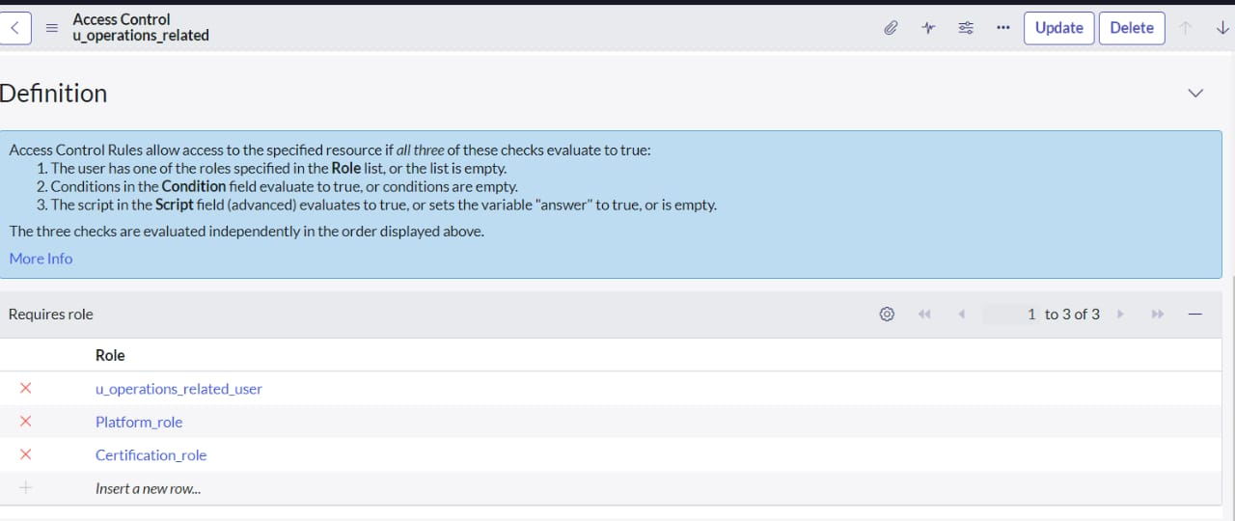
15. Click on u_operations_related write operation
16. Under Requires role
17. Double click on insert a new row
18. Give platform role
19. And add certificate role.